UNIVERSE
A SuperCollider additive synthesis score
Petros Tatsiopoulos
2015-20125

Tone degrees: ton_cosmos, ton_galaxy, ton_sun

Tonal choice: a location is chosen from the given object ‘Spherical(mag, az, el)’.
Magnitude represents the tonal degree of the respective object as unrounded float, and azimuth, elevation the location on VBAP. This means points closer to the origin have a lower tonal degree and higher amplitude. Every object has a min. tone degree of 0, thus a fundamental multiplier of 1, therefore the min. (eg. in the case of sun or galaxy, ‘black hole’) frequency of each object corresponds to the relevant band.

Frequency bands: 12Hz, 56Hz, 992Hz, 16256Hz
6Hz 28Hz 496Hz 8128Hz

Fundamental: 1Hz

Sawtooth: m; m bank dependent on location magnitude as rounded intervals eg. mag=bank=28

Osc freq: (fundamental*ton_cosmos*ton_galaxy*ton_sun) *m

Osc: amp: as above .reciprocal

Aperiodic nature: Osc is an aperiodic wave, either through fm classic, or fm via additive synthesis (see tonal_fm.scd file). All diferent object arrays, different suns, different galaxies, different cosmoi, have standard properties and structure abut are different point and modulation phases each time, thus array creation, relevant envelopes also aperiodic.

////////////////////////////////////////////////////////////////////////////////////////////////////////////////////////////////////////////////
Control layers:

- Pattern: sets control parameters on all Routines and SynthDef, each event under \dur is represented as a new cosmos, therefore each event is a cosmos envelope with total duration in which and according to its state through time, the corresponding nested envelopes for galaxy and sun.
- Routine A: sets a choice of galaxy from the possible locations in the cosmos array. ‘nest0’
- Routine B: sets a choice (eg. three choices per galaxy) of sun from the possible locations in the galaxy array. (note at the early stages of the cosmos the galaxies are super-suns and after their collapse they develop to galaxies, hosting suns), ‘nest1’
- Routine C: sets a choice of area on the sun from the possible locations in the sun array, time eg. four choices per sun.

////////////////////////////////////////////////////////////////////////////////////////////////////////////////////////////////////////////////
Timeline and envelope control:
- Cosmos: points are disperse, forming no object, as the universe expands points start to form super-suns(ss) , then galaxies from the ss black holes and other suns and solar systems (Figure1). If we suppose the universe ha no origin (point of origin as spatial property of the object is to be more correctly understood geometrically as temporal not spatial), then its object, if a cube, starts with a ‘bing bang’ where all points are completely dispersed and close to each other forming only their total group. As time passes (away from origin), points form groups, which in turn form bigger distances to each other gradually, than the individual points (monads) used to have. As time progresses even further the groups from ss turn to galaxies (first sun deaths), and other suns clump as groups in the galaxies, forming thus a final grouping and distribution of point as galaxies (Figure1, 9th state). Further in time as more suns die and become one with the center of galaxy supermassive black holes, and more and more supermassive black holes and galaxies fuse together and collide, distances become bigger further still and the gravitation of single groups even larger. When all points have clumped to a n number of ss black holes , (eg. because of cube model: 8 points), remaining groups have such large amount of gravitation that locations collapse even further the largest distance of 2 points and diagonal of the cube. During this state the two super groups collapse to each other forming one clump which in turn collapses to itself as spacetime itself. The result of this collapse is a big bang and a new cosmos again same in structure and timeline but different in character and duration, (aperiodic oscillation and aperiodic envelope).
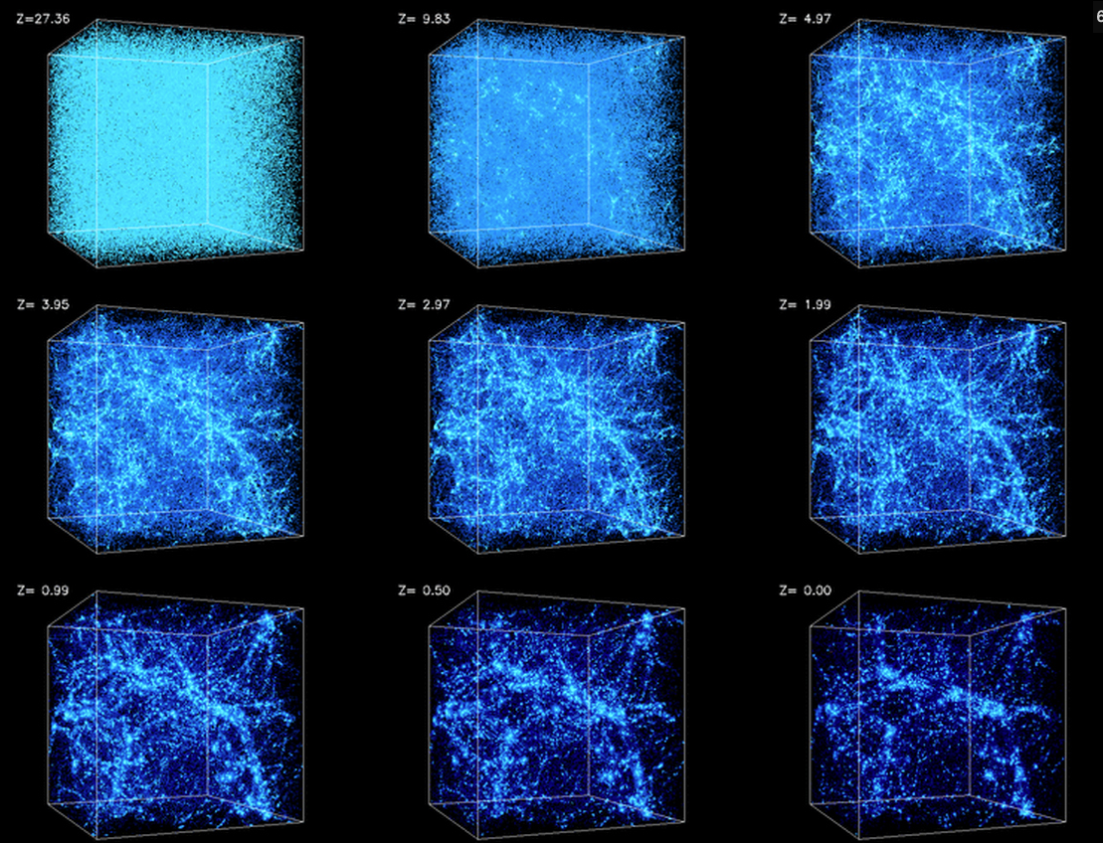Figure 1: By Andrey Kravtsov (the University of Chicago) and Anatoly Klypin (New Mexico State University) - http://cosmicweb.uchicago.edu/filaments.html, CC BY 3.0 us, https://commons.wikimedia.org/w/index.php?curid=10471335
- SS, super suns, are the first suns that form which when collapse form a supermassive black hole which groups other later suns to galaxies.
- Suns are created by the gradual grouping, (vortex), of points until they form a core.l This core indicates a gravitational field which draws even further points to itself the sun becomes larger to some extent and engages in fusion. When the fusion collapses, the sun collapses and turns to a black hole.

////////////////////////////////////////////////////////////////////////////////////////////////////////////////////////////////////////////////

